East Asian Film Literacies
National Resource Center for East Asian Studies
Earl Jackson, Jr.

2. Beyond the Fog and the Samurai:
Japanese Cinema for Real

Earl Jackson, Jr.
University of California, Santa Cruz

Generally speaking, in the United States, the phrase, “Japanese Cinema” evokes either the samurai-disciplined aesthetic austerity of the Kurosawa-Ozu-Mizoguchi trinity or a long-running shaggy-dog story in rubber monster suits. The persistence of these two alternatives as the western definition of Japanese Cinema suggests a vicious circle. These expectations were originally created by the handful of Japanese films that reached the U.S. Once these notions of Japanese Cinema were in place, however, those very notions, in turn, determined what subsequent films would get released in the U.S., what directors would come to represent "Japanese film" and which ones would be left out of the picture altogether.
Here I would like to sample moments in Japanese cinema history that have been left out of the U.S. version. This is only a portion of what is out there, but not a random choice. I will begin by looking at certain films which fall under both categories acknowledged in the American myopia: samurai and horror. My examples will in turn serve as an introduction to the work of their director, Nakagawa Nobuo (1905-1984), who began his film career in 1929 as assistant director for Makino Masahiro. He debuted as a director in 1938, but he made his most remarkable films for the Shin Toho studios from 1956-1960. He was a horror filmmaker’s filmmaker, as attested by the praise he has received from contemporary admirers Nakata Hideo
(Ring) and Kurosawa Kiyoshi.
Plot summaries of Nakagawa’s films may seem quite formulaic: the samurai films deal with revenge, and the ghost stories enact vengeance. But this judgment needs fine tuning – these films are actually concerned with retributive justice. And the ghosts are not so much creatures of rage as a premodern form of inscription – apparitions that insistently remember crimes that the living choose to forget. The insistence on remembering figures prominently in virtually all of Nakagawa’s later work. He used the cinematic apparatus as a technology of historical memory approximately at the time other studios used it as a technology of forgetting (the war, the consequences of ultranationalism, etc.). In 1956 Nikkatsu ignited the youth-film craze known as Taiyozoku (sun cult) with adaptations of the novellas of Ishihara Shintaro. In 1959 Kobayashi
Akira, the “Might Guy” will begin to wander with guitar in hand around Japan and eventually Asia as the Mukokuseki (Nationless) in the nine-film Watari-dori series.

Kaii Utsunomiya no Tenjo

One of his earliest films from this period, Nakagawa Nobuo’s Kaii Utsunomiya no Tenjo [The Ceiling at Utsunomiya] (1956), seems to meditate on other aspects of film technology through analogies in the plot devices. That is “plot devices” in which both are to be taken literally, since the plot of the film is a plot to kill the Shogun with a very complex device, a ceiling filled with rocks, and suspended by hidden ropes and wenches that can be lowered mechanically. The mastermind is the Daimyo in Utsunomiya castle. He and his financial backer employ dozens of carpenters, stone cutters, and manual laborers. Because the nature of the device must remain secret, the three groups of workers are kept confined separately to prevent them from comparing notes. In the scope of the production and its use of multiple forms of technical know how, the project resembles the production of a film, while the secrecy concerning the goal and the quarantining of the workers becomes a satirical illustration of alienated labor in the Marxian sense.
Images of deadly machinery appear several times in the film, serving to anticipate the completion of the ceiling and allowing the associations between machinery, death, and cinema to proliferate in both the plot and the visual presentation. In most samurai films, the highpoint of contact between opponents is the swordfight. Yet Tenjo withholds the satisfaction of direct combat by allowing the villain (Tanba Tetsuro) to use his sword to sever the connection between the pulleys and the chair as the hero (Ogasawara Ryuzaburo) was taking across the mountain chasm. In the typical combat scene, the quick edits derive their tension from the depiction of each man’s individual strength and skill with the sword. In this scene, the tension comes from the seated man’s distance from the opposite cliff, the length of the rope, and the rope’s resistance to the sword blade. In other words, the suspense is not divided between two human agents, but dissipated in the incalculable physics of the mechanism and its interruption.

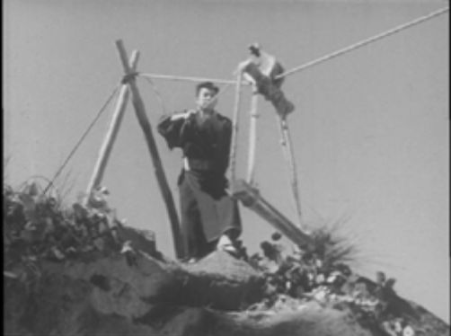
2-1 The Ceiling at Utsunomiya (Japan, 1956) Directed by Nakagawa Nobuo, Shintoho Company Production
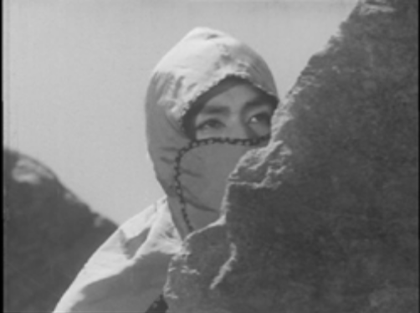
2-2 The Ceiling at Ustunomiya

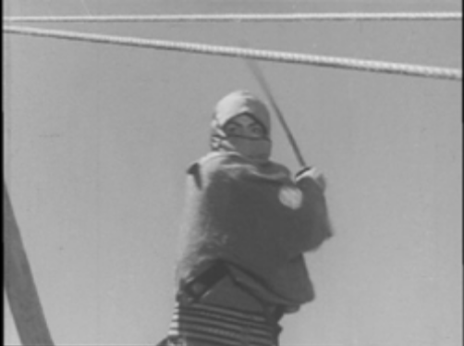
2-3 The Ceiling at Ustunomiya
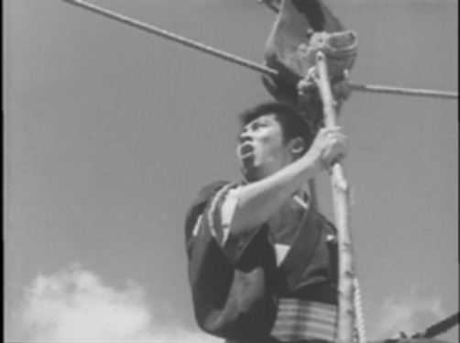
2-4 The Ceiling at Ustunomiya
This scene, in which the pulley facilitated the commission of a crime, is counterbalanced by a scene in which a pulley facilitates retribution for a crime. Moreover, the appearance of the agent of the retribution (appearance not in the sense of what he looks like but how he manifests himself) suggests precursors to the cinema.
It opens in the merchant’s mansion, where, like a film producer, he is counting money. The man hears something outside and sees a figure silhouetted through the shoji screen, but when he pulls it open there is no one there. But the pulley in the well is turning by itself and soon pulls up the living corpse of someone the merchant had killed and deposited there.

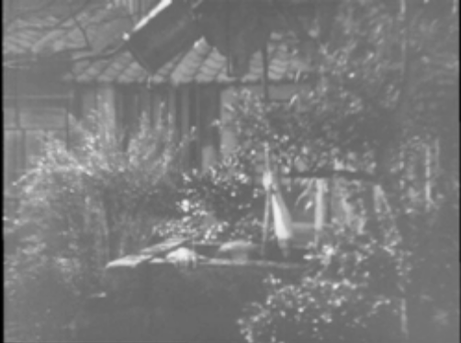
2-5 The Ceiling at Ustunomiya
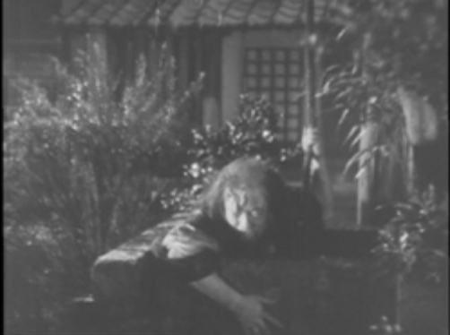
2-6 The Ceiling at Ustunomiya

The daimyo and company have their hands full in the weeks prior to the Shogun’s visit. Besides completing the ceiling and keeping it secret, they also have to direct their spies in discovering and neutralizing any spies the Shogun may have sent ahead. Much of the film concerns the attempts of the Shogun’s spy to discover what is going on in the castle and then to get the information to the Shogun in time. Through a great deal of struggle and personal sacrifice, the Shogun’s agents learn of the Daimyo agents’ plot and succeed in warning the Shogun. The Shogun, however, proceeds with the visit as planned. The Daimyo and his retinue welcome the Shogun and his in the newly finished room, a very grand reception hall. Far above them, in the rafters over the ceiling, two of the Daimyo’s henchmen hold one of the imprisoned carpenters at sword point, indicating when the man is to cut the ropes and seal everyone’s fate below.
The Daimyo bids the Shogun a good rest and prepares to leave, when the Shogun halts him (and everyone else), announcing he is going to perform a dance. The dance is the kusemai finale of the warrior Noh play Kiyotsune. Like most of the warrior Noh plays, this one deals with a member of the Heike clan, the losing side of Genpei civil war. But Kiyotsune is an unusual figure, because he did not die in battle, but committed suicide by throwing himself in the ocean. The Noh play recalls the dilemma that Kiyotsune had found himself in, having taken refuge with people who were supposed to be allies that actually were not. This is the same predicament that the Shogun is in, albeit deliberately. And his deliberate choice to come to the castle, and even more so, to dance Kiyotsune underneath that ceiling may be a suicide like Kiyotsune’s. Kiyotsune should not have gone to the Asura hell, the one reserved for warriors who die in battle, but he experienced the Asura hell while still alive, in seeing all elements of his environment as hostile enemies. The dance the ghost of Kiyotsune performs and the song seem to describe the mythical world of the Asura but actually describes the real world he lived in. By the same token, the lines of the Noh sung while the Shogun dances simultaneously describe Kiyotsune’s situation and the Shogun’s. The language of Noh is highly allusive using pivot words (kakekotoba) and puns based on homonyms. There are many of both in the text of Kiyotsune. In this passage the puns show the psychology of Asura hell: the words on one level describe unmarked nature, but on the level of the pun denote hostility and strife. In the table below I excerpt some of the lines from the kusemai, and provide both literal level and secondary level meanings. The final line, I argue, has an added meaning specifically in the performance within the film that it would not have in the original Noh.

Literal Level Meanings | Secondary Level Meanings
Sate shored ni ochikochi no | “Falling into the Asura Hell”  And “here and there”
Tazuki wa kataki ame wa yasaki | The standing trees are enemies  And the rain tips of arrows
Tsuchi wa seiken yama wa tejjoo | The earth itself is a sharp sword  The mountain an iron castle
Kumo no hatate o tsuite | Meaning 1: Arriving at the far ends of the clouds.  Meaning 2: The clouds are battle flags  A dagger pierces
Geni ni mo kokoro wa kiyotsune ga | In truth my heart is purified [kiyo]  In truth my heart Kiyotsune
Bukka o eshi koso arigatakere. | 1. has attained Buddha hood.  2. *** I have found the weapon!*film-only meaning

Furthermore the rigidly precise structure of the kusemai allows the shogun to raise his sword against the Daimyo seated in the audience, since that movement is required by the choreography at the time, yet another overlap between the performed fiction and the actual situation. The scene in the room is intercut with the action above. At one point the henchmen hit the carpenter with a sword, mirroring the Shogun’s gesture at the Daimyo.
The intercutting is an address to the spectator and in underscoring the spectator’s greater access to the scene, it also recasts the architecture into a model of the film’s structure into two
levels – the lower level of the fiction and the higher level of the presentation. The room is the space in which the fictional drama of the Shogun and the Daimyo occurs, and within that fiction, the Shogun performs the fiction of Kiyotsune. This narrative embedding in the structure causes a reversal in the plot: the would-be victim becomes victimizer in his deliberate enactment of an already vanquished victim; the would-be assassins now held in their own trap.
The scene is structured, controlled and maintained within the kusemai of Kiyotsune. It lasts the length of that performance. Since the form of a kusemai is basically invariant across all second category Noh plays, the tension here is enhanced by a knowledge of the play and specifically by a knowledge of the conventions of the dance itself. Each step can be anticipated by the knowledgeable spectator, as well as the time it will take to complete.

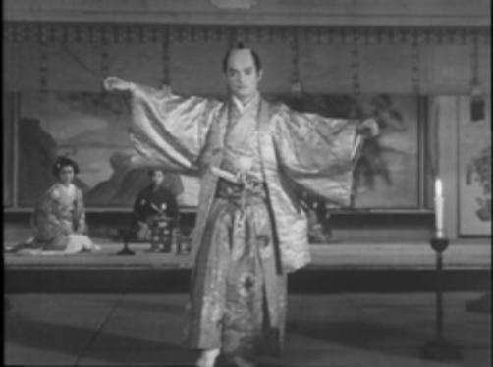
2-7 The Ceiling at Ustunomiya
Furthermore, the points at which the dancer will brandish the sword, and where and when he will point it are also fixed, thus the gestures of the Shogun are at once deliberate and literally pointing at his real enemies and simply dictated by the pattern of the kusemai. 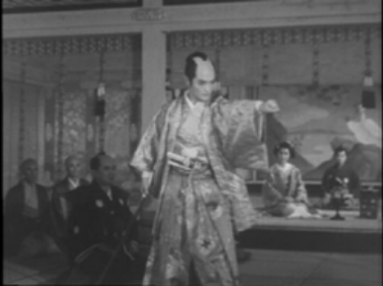
2-8 The Ceiling at Ustunomiya
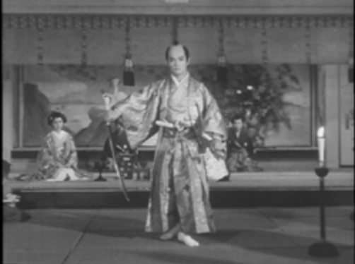
2-9 The Ceiling at Ustunomiya
While the performance is the structure and the duration of the scene in toto, the scene on screen intercuts from the room where the performance is going on, to the secret chamber on top of the ceiling. The action varies from the Shogun’s dance to the conspirators forcing their prisoners at sword point to turn the wenches that will bring the ceiling and its rocks down to the floor below.

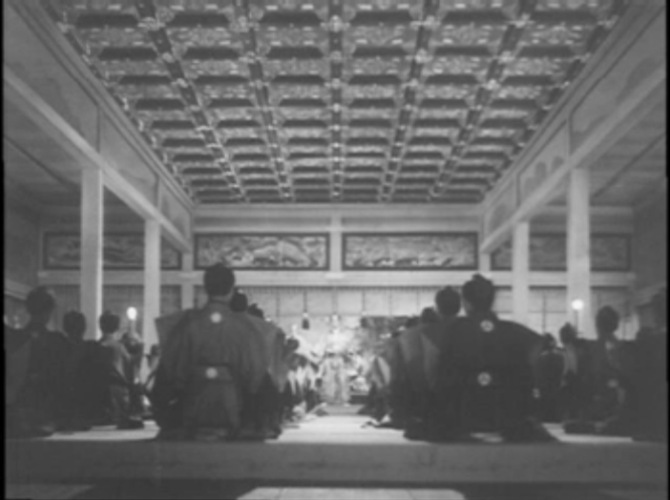
2-10 The Ceiling at Ustunomiya
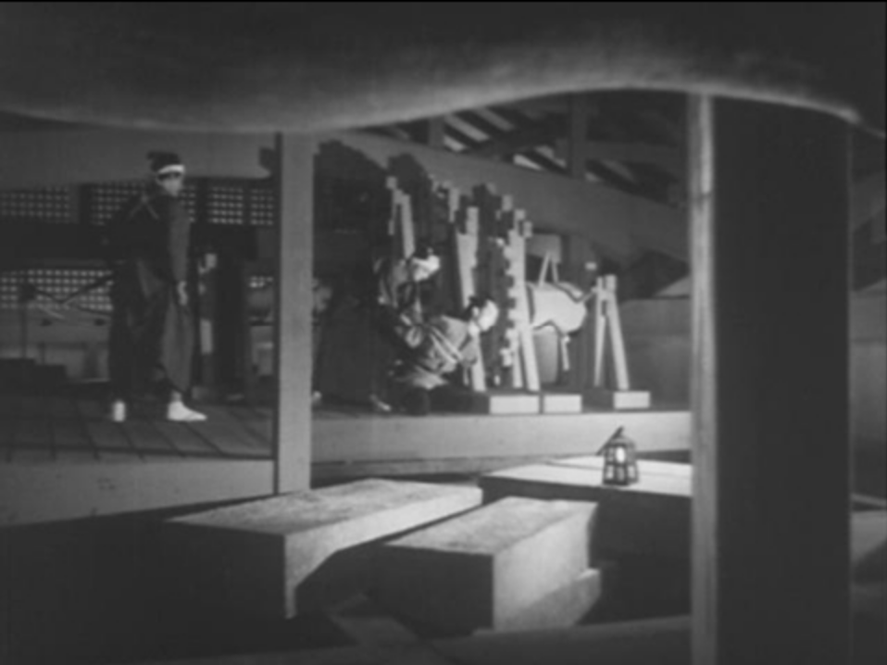
2-11 The Ceiling at Ustunomiya
The split scene of action lends another dimension to the specific gestures of the performance on both the level of representation and on the level of the plot. On the level of representation, the close-ups of the Shogun’s feet underscore visually how the rhythm of the dance intermeshes with the rhythm of the intercutting between scenes.

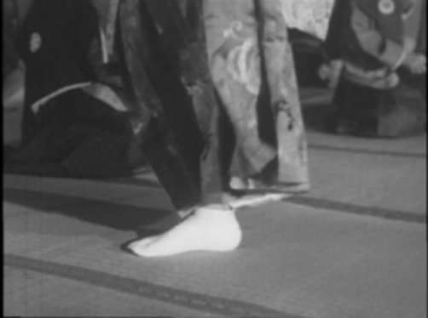
2-12 The Ceiling at Ustunomiya
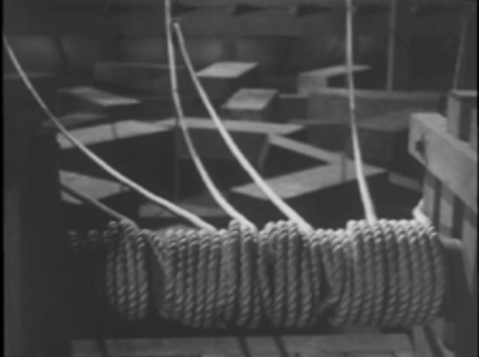
2-13 The Ceiling at Ustunomiya
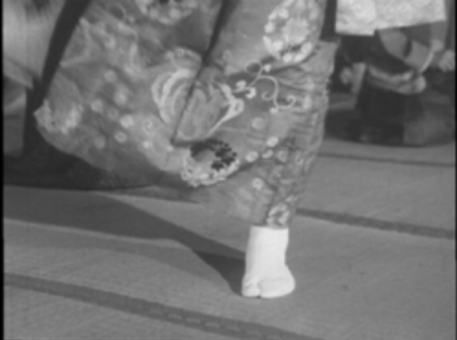
2-14 The Ceiling at Ustunomiya
On the level of the plot, for example, the point at which the Shogun as performer points his sword outward – is doubled: not only is he actually pointing it at his host who masterminded the shogun’s assassination, but is paralleled with the conspirator’s sword threatening the hapless carpenter above.

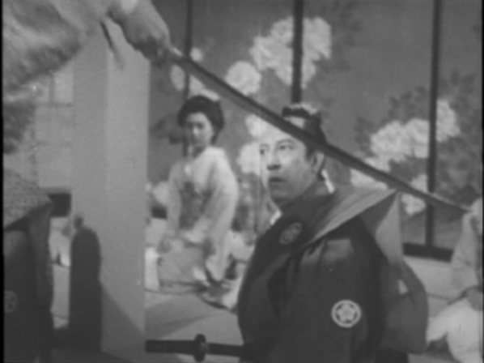
2-15 The Ceiling at Ustunomiya
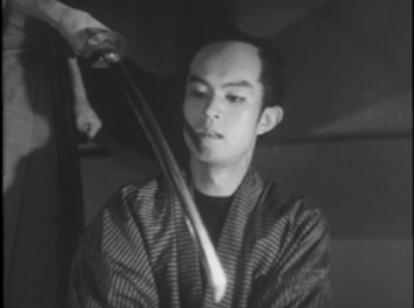
2-16 The Ceiling at Ustunomiya
Immediately after the final note in the kusemai is sounded, the ceiling begins to collapse. The Shogun dodges the stones and captures his macabre hosts.
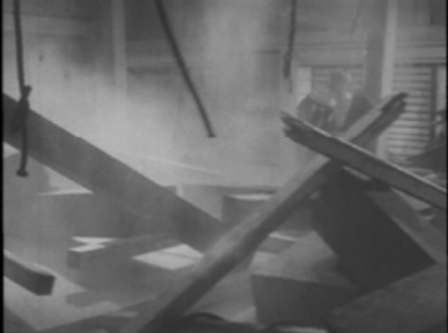
2-17 The Ceiling at Ustunomiya
The film ends with the Shogun’s procession returning to his domain, with the spy leading the way. He bids farewell to the woman who had helped him. It is a downbeat ending, not only because the two do not become lovers, but because there seems to have been nothing to celebrate. The shogun’s decision to dance in that room might show courage but it also shows complete disregard for human life. Many who stayed for the dance were killed by the ceiling, including his own men. So the efforts of his agents and their nobility in serving him simply resulted in the Shogun’s power and ruthlessness remaining uncontested. And I don’t believe I’m doing a resistant reading here- I believe this is Nakagawa’s point – the way it is shot encourages disappointment and critical questions.

The Way of the Samurai

Nakagawa’s samurai films demonstrate a sustained contempt for the code and the hypocrisy it supported. Samurai are always flying off in a rage when they are accused of something they have done, and they always feel justified in killing the accuser, never noticing that not only was what the accuser said true, but that committing murder made them even less honorable and less worthy of the respect they demanded.
In Kaidan Kasanegafuchi (The Ghosts of Kasane Swamp, 1957), the blind masseur Soetsu braves the snow to visit the well-to-do samurai Shinzaemon in hopes of collecting the money the latter owes him. When the samurai says he does not have any, Soetsu asks how that is possible. Good question. But that question suggested that Shinazaemon is a liar or a deadbeat, an insult that earned Soetsu a bloody death and a grave at the bottom of the Kasane swamp. Of course Shinzaemon was lying and was a deadbeat.
In Borei Keibyo Yashiki (Black Cat Mansion, 1958), Ishido Shogen (Shibata Shin) is a bad tempered beginner at go, and Kokingo (Nakamura Ryuzaburo) attempted to teach him the game, but ended the session because the Shogun cheated. Enraged at being accused of cheating, the Shogun killed Kokingo. Of course, he cheated.

The Representation of Representation.

Another characteristic The Ceiling at Utsunomiya shares with other Nakagawa films is its representation of the act of representation. Take, for example, the parallel between the construction of the ceiling and the production of a film. The title sequence confirms the parallel and identifies the film as a whole, with the technological motifs and metaphors of the narrative. The background of the title is the completed ceiling. But because this direct shot has no spatial orientation, instead of the ceiling appearing to be a ceiling- and properly above our heads, it is flush with the surface of the screen – intimating that the film itself is the ceiling of doom. The credits then take on the meditations and mediations of light and shadow, projection and framing, as the camera tilts from a direct shot of the ceiling and slides through uneven rows of bamboo screens and translucent shoji, at times illuminated by lamps or flames of varying intensities. The directly filmed screens are further complicated with both rear projection and superimposed images of other shoji and porous barriers to the light. The actual movie screen on which the film is projected becomes a palimpsest of screens and projections.
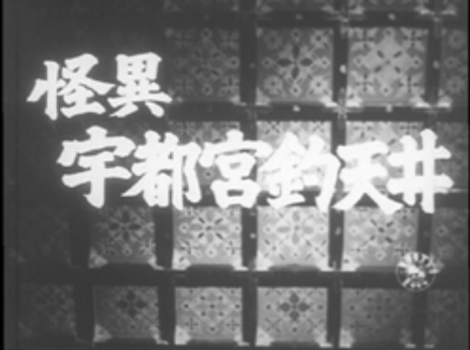
2-18 The Ceiling at Ustunomiya
Figures 2.4a 2.4b 2.4c.

The representation of filmic representation is also frequently associated with the uncanny. The revenge of the dead man from the well, in the scene mentioned earlier, is presaged with a ghostly shadow apparently cast by no one. We see the producer’s money counting interrupted by not the ghost itself but the cinematic exposure of the process of projection of an entity no longer there, no longer alive (which is also true of the projected entities on screen for the viewer of the film).

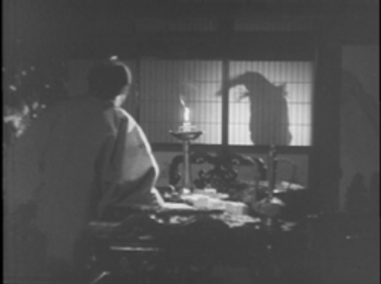
2-19 The Ceiling at Ustunomiya
Other films also invoke screen technologies. The title credits of The Ghosts of Kasane Swamp feature painted figures that seem to be taken from the first and final panels of a popular medieval picture scroll depicting the nine stages of the decay of the body of renowned Heian poetess and beauty Ono no Komachi.
The source for The Ghosts of Kasane Swamp also suggests Nakagawa’s interest in technologies of memory. The story was originally composed by the yose story teller Sanyutei Encho. Takusari Koki (1854-1938) invented a Japanese shorthand called sokki. In 1884 Wakabayashi Kanzo was commissioned to transcribe the live performance of yose storyteller Sanyutei Encho, Kaidan Botandoro (The Peony Lantern). The transcription was then transferred into kana and kanji and published in book form. This began a new genre of book deriving from the live performances.

BOREI KEIBYO YASHIKI (Black Cat Mansion)

The inscription of the past plays an urgent role in Nakagawa’s work. Black Cat Mansion links the past and the present in complex structure. It opens in the present (1958) in the basement offices of a hospital during a blackout. The halls and objects are visible only as a flashlight crawls over them, revealing bodies being carted to the morgue, and plastic life-size models of human beings cut-away to various levels of internal organs. The story begins with the doctor sitting in the dark, recalling an experience from eight years ago. This begins a flashback. His wife had TB and he was moving his medical practice down to her home village in Kita Kyushu so she could recover. They set up house in the family ancestral home which is a labyrinthine and morbid environment. She is attacked several times by a weird old woman. Her younger brother learns the reason for this from the village priest. Up until this point, the film has been in black-and-white, with a haunting blue tint. When the priest begins to tell the history, the scene shifts to brilliant color. It is set in the early Edo period and involves the Shogun, his hapless go teacher Kokingo, and Kokingo’s cat who loves him. After the Shogun murdered Kokingo, he raped Kokingo’s blind mother. Before she commits suicide she asks the cat to take revenge. The cat possesses the Shogun’s mother and kills his retinue. As it turns out, the modern wife must be a descendent. But the curse stops when during a violent storm a wall is ripped open revealing the remains of Kokingo hidden there. When he is given a proper burial, the curse subsides.
The crime of the past was brought to light and appropriately acknowledged. This allows the narrative to return to the present of the frame – 1958, not 1950.
In the present atmosphere of Neonationalist rhetoric, and the movement to censor history textbooks in Japan, the conclusion I have just drawn from the film’s conclusion certainly suggests the question of facing the responsibility for the War. And the final film I will read at any length, tends to support this supposition.

KEMPEI TO YUREI (The Kempei and the Ghost)

In 1958 Nakagawa made Kempei to Yurei (The Kempei and the Ghost). The Kempei was a special branch of the Japanese military with civil police powers and duties. It came into being to enforce the Peace Preservation Act of the 1920s. The Kempei were also charged with guarding military secrets, undermining foreign governments, and controlling the domestic populace. As World War II intensified, the Kempei’s authority became virtually boundless, and their reputation for utter cruelty became legendary not only abroad, but at home as well.
This subject, therefore, would certainly make many people uncomfortable in 1958, only fourteen years after the end of the Kempei. And the opening scene is also a shock. The credits appear over a military parade crossing a river through a neighborhood and into the Tokyo Headquarters of the Kempei. Crowds of onlookers cheer and wave flags, and the soundtrack is a woman soloist and chorus singing one of the famous militant songs of the time.

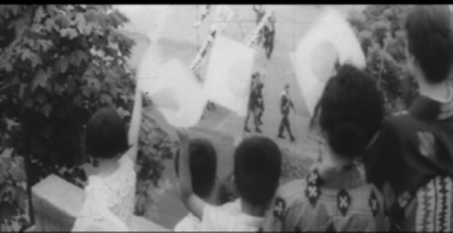
2-20 The Kempei and the Ghost (Japan, 1958). Directed by Nakagawa Nobuo, Shintoho Company production.
Against this disquieting historical horizon Kempei and the Ghost presents a real horror story of a psychopath given free reign to his urges by the very highest institution of law. Kempei chief Namishima attends the wedding of Officer Tazawa Ichiro (Nakayama Shoji) to Akiko (Kubo Naoko), while plotting how to win her away from her groom. The next day, Namishima tells his second-in-command (Nakamura Akira) that a briefcase with military secrets is missing. The second-in-command realizes that this breach of security would mean his court martial and probably execution. He begs Namishima to think of a way out. Namishima instructs him to plant an empty briefcase among Tazawa’s things and then to take him in for questioning.
“Questioning” entails hanging Tazawa upside down from the ceiling with his arms bound behind his back and beating him with a stick until he becomes unconscious whereupon he is doused with water and the beating recommences. Tazawa refuses to confess, and so his bride and his mother are brought in and tortured in front of him. As a soldier prepares to break his wife’s fingers, Tazawa confesses. He is executed by a firing squad. Before he dies (and perhaps after too) Tazawa repeats a line that could be emblematic for most of Nakagawa’s work. “I will not forget!” One soldier in the squad fainted, it was Tazawa’s younger brother (also played by
Nakayama Shoji).
Recall that the second-in-command does all this knowing Tazawa to be innocent. This makes it an even more of a cutting critique of Japanese history in that an order from the Kempei was to be considered a direct order from His Imperial Majesty the Emperor. Meanwhile, Namishima takes the secrets (that were not missing) and sells them to a Chinese spy (Shibata Shin). He also meets Koh-Ran, a sparsely clad nightclub singer from Shanghai (Mihara Yoko), who turns out to be married to the spy.
The ordeal of her son’s execution was too much for his mother – Namishima has her hospitalized. While visiting her, he convinces that she is too much of a burden on her daughter-in-law, and persuades her to commit suicide. He then visits the widow, and eventually rapes her and then discards her when she becomes pregnant with his child.
The second-in-command is suffering from pangs of conscience; he drinks heavily and starts to hear what he believes to be ghosts. Eventually he confronts Namishima and Namishima kills him and slices the body into pieces small enough to fit into two sea-crates, which he tosses overboard the ship taking him to his new mission in China.
He is assigned to investigate security leaks, and ironically the officer assigned to assist him is Tazawa’s younger brother. The Chinese spy-couple also turn up in the city, and even Akiko is now a military nurse in a hospital not far from Namishima’s new headquarters.
The film is much more profound than the sordid plot summary indicates. The film’s set design and camera work are practically philosophical statements. They configure the drama, the politics, and the fantasies out of control perfectly. The sets and the camera angles, movement, and lighting are simply startling – I know of no other film from this period that shows this kind of creative edge.
For example, the first Tazawa torture scene is initially shot from between the boots of the second-in-command, directing the beating and watching Tazawa swing from the ceiling – Tazawa’s body is perfectly centered suspended between those two military tall boots. When he passes, the camera switches to an impossible shot directly overhead of the rope tied to the ceiling so that the body seems to be hanging directly down from the camera lens itself.
This innovative camera technique is also part of a two-scene sequence that is as stunning for its political message as it is for the technique of its delivery. The shot the dangling officer transitions with an abrupt cut to a medium close-up of a Japanese flag, framed and hung in a place of honor in a tokonoma, a samurai sword leaning nearby. The shot is still for a few seconds, and the soldier, who had just been knowingly torturing an innocent compatriot, juts into view, centering his head and shoulders with hi-no-maru in the center of the flag. The initial segue identifies Japan itself as the origin of the evil perpetrated, and the sudden self-insertion of the soldier dramatizes how an individual assumes a position within that Imperial sociopathic system.

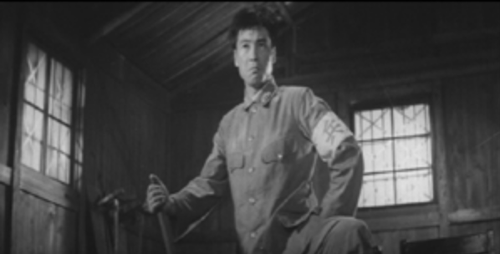
2-21 Following the orders of his commander, the lieutenant supervises the brutal “interrogation” of the soldier he himself had framed. The Kempei and the Ghost

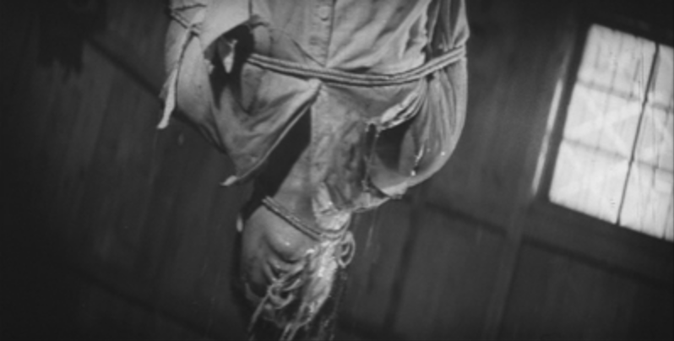
2-22 The Kempei and the Ghost

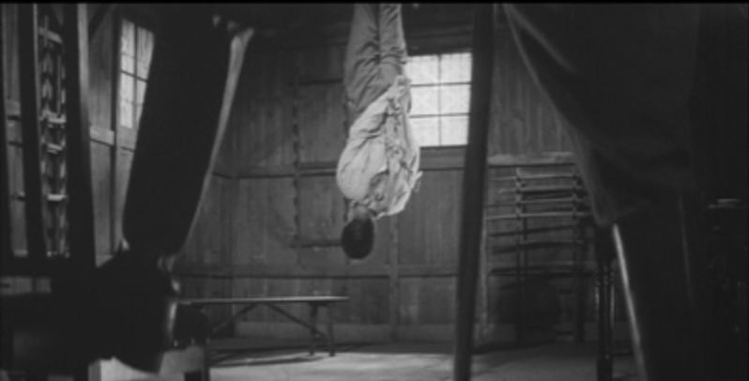
2-23 The shot through the military-booted legs and the victim, frames the atrocity while commenting on it. The Kempei and the Ghost
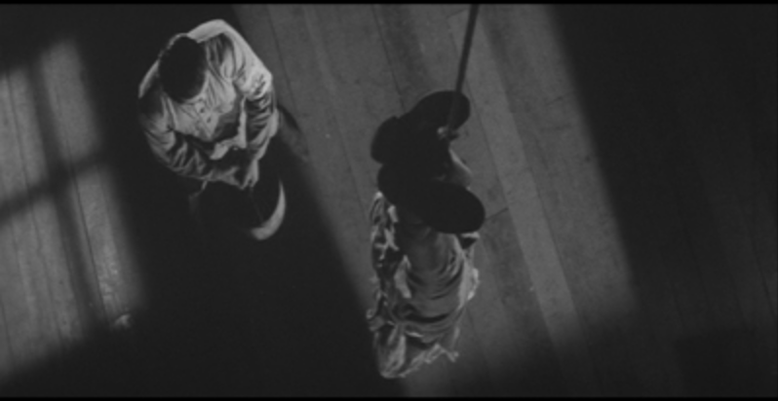
2-24 The kempei test the limits of their victim, while the cinematography tests the limits of the spectator’s habits of viewing. The Kempei and the Ghost

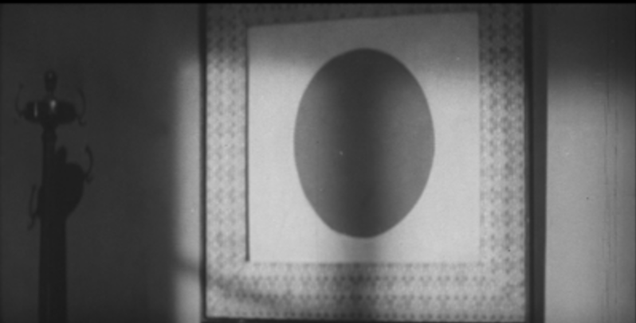
2-25 The Hi-no-Maru and the Samurai Sword, the symbols of Nippon, one body, united in Service to the Emperor. The Kempei and the Ghost

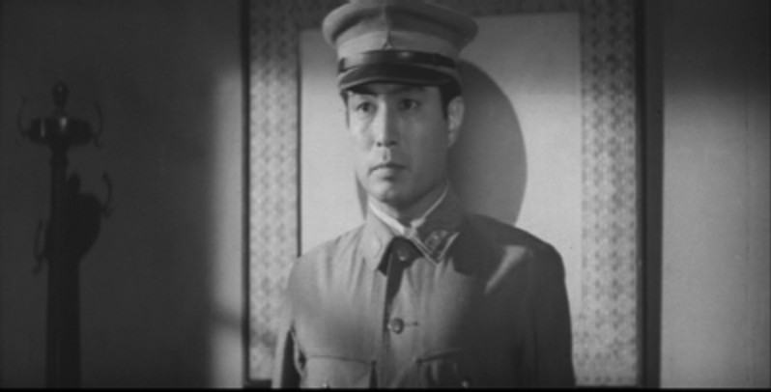
2-26 A soldier assumes his position as proper Imperial subject. The Kempei and the Ghost

When the second-in-command starts drinking, the camera sways from side-to-side, and its movements become more radical as his mental state deteriorates. In the fatal confrontation between the second and Namishima, the camera also occasionally rolls on a 180۫ axis, but the set representating the bedroom is also literally structured at a 45-degree, and as the action picks up, the entire set rocks back and forth in one direction while the camera sways in the opposite direction.
At times the figure of Namishima is doubled and captured perfectly in the opaline blackness of the Chinese spy’s sunglasses.

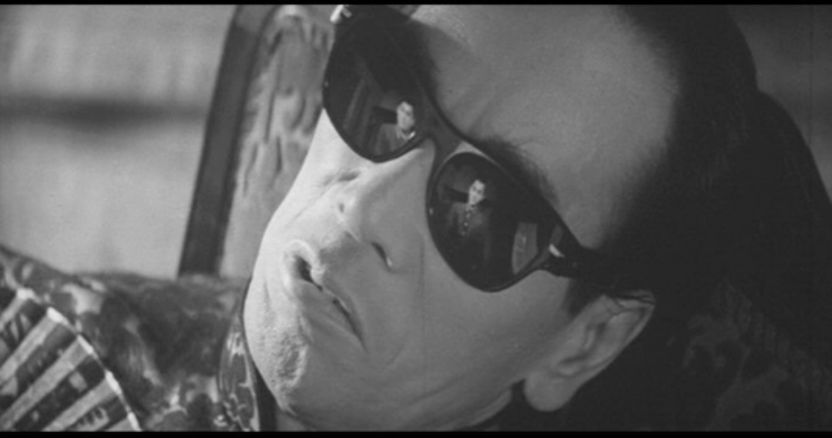
2-27 It seems as if the Japanese fascist fantasy of China becomes a mirror for the fascist fantasy of the Japanese self. The Kempei and the Ghost

Needless to say, things fall apart for Namishima in China. He is brought to justice and Akiko and her brother-in-law learn the truth.
One of the most striking images is the final scene, in which Akiko and her late husband’s brother say farewell. They are standing on the edge of either a stone wall or a dam. The scene is held in long shot and at an oblique angle to the plane on which they stand. Figure 2.28.
They are tiny figures in the upper right hand corner of the screen. Most of the screen is covered by the cobbled surface of whatever structure it is, leaving only a rip of white sky at the top where the figures find to stand. When they speak each person is shot individually in medium close-up. Figures 2.15a; 2.15b Each looks directly into the camera and there is an eyeline match. But these shots seem abstracted from the location of the long shot, making that landscape all the more uncanny when the screen returns to it, this time with the two of them walking uphill, in single file. Stranger than the visual disorientation of this scene is the way in which this disorientation makes perfect sense. It expresses poignantly and overwhelmingly the crisis these two people now face. The monster Namishima is now gone. But there are many more. And in fact, both Akiko and Tazawa are part of the Ultra-nationalist machinery that made Namishima possible. They have no idea why they are in China or what it means to be an ethical, rational human being in the system that brought them to this very foreign land. They are each alone with their ethical aloneness, unwilling invaders from a country that is no longer theirs either. The final image of them walking uphill toward an empty sky is a remarkable tribute to the many Japanese citizens who must have suffered such an isolation.

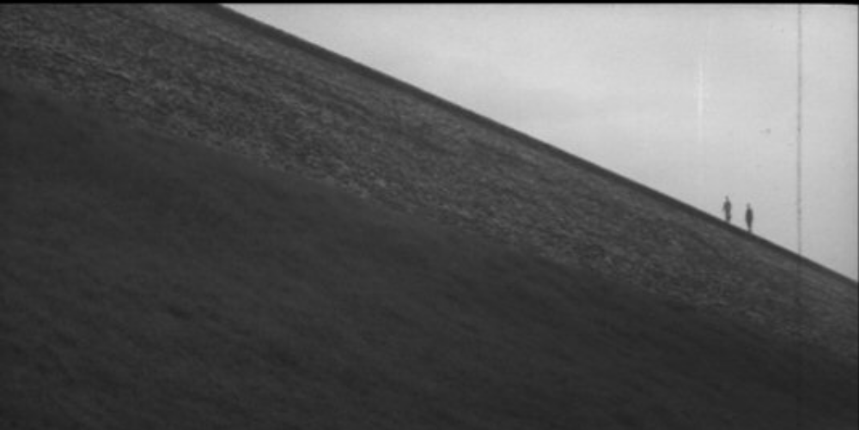
2-28 The Kempei and the Ghost
It is regrettable, however, that Nakagawa had not taken the more radical step of empathy outside of the Japanese borders, especially in films such as Kempei and the Ghost, Japan itself had so catastrophically expanded those borders. It is certainly to Nakagawa’s credit that he exposed the reign of terror in which the Kempei held the Japanese people. But, like so many other Japanese films dealing with World War II, Japan appears as the sole victim.
The setting of Tazawa’s execution as a crucifixion is extremely effective in expressing the injustice of that act and raising the incident to an emblem of the suffering inflicted on all the innocent of the nation. But there are other implications of the imagery as well. The cross, of course, alludes to Christ. But was Tazawa taking on the sins of his Emperor in order to save the nation? Let us recall Tazawa was also an exemplary soldier with an excellent record, which means that until that time he had been fully involved in advancing the causes of the Japanese military, and had he not been executed he would have continued to pursue that campaign. The nobility of the death allows the injustice rendered to Tazawa to completely eclipse the massive scale injustice wrought on the entire Pacific, an injustice which Tazawa had devoted himself to as well.

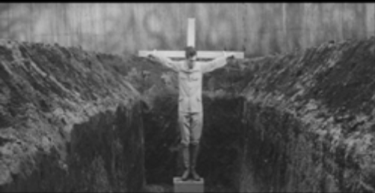
2-29 A Christ figure? The Kempei and the Ghost

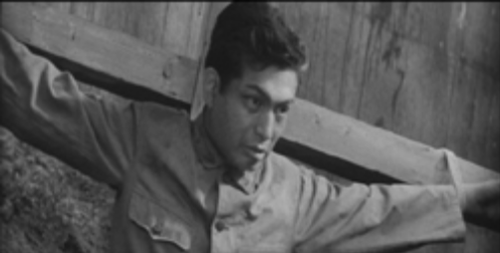
2-30 The Kempei and the Ghost
Similarly, Namishima’s selling of secrets to the Chinese is an audacious expose of the hypocrisy of the Japanese military at the time, and the emptiness of its ideology of loyalty. While his motivations are purely selfish, the Chinese buyers are portrayed as figures who share Namishima’s amorality. The film never asks or answers questions about their motivations, nor does it even offer the most obvious one: namely that they may not be acting out of greed (indeed, purchasing the information does not profit them at all), but out of patriotism. Namishima stole the secrets as part of a plot to get rid of a rival of a woman he desired. Somehow the wickedness of his motivation lends a sinister affect to the parties who purchased the secrets. But is it not possible that they were fighting for the liberation of their country? By not asking this question, and by associating the spies with criminality, the film is in effect identifying nations who resist the Japanese conquest as evil, thereby subliminally continuing the very Imperialist ideology that the film as a whole condemns.
To confront the ideological shortcomings of the film is part of an ethically rigorous critical practice. But such a challenge to the work of Nakagawa Nobuo does not denigrate his achievement, but in fact is another way of taking Nakagawa’s own critical inquiries seriously – to extend their spirit and to break even more laws that constrained them.

Nakata admits in an interview that his form of horror is indebted to the classic ghost story film versions of Yotsuya Kaidan. Of the six versions made, his favorite is Nakagawa Nobuo’s Tokaido Yotsuya Kaidan (1959). Fangoria 192. Kurosawa includes Nakagawa’s Tokaido Yotsuya Kaidan and Borei Keibyo Yashiki in his list of fifty best horror films. Kurosawa Kiyoshi, Eiga wa Osoroshii. (Tokyo: Seidosha, 2001): 31, 41.
? For detailed descriptions of the kusemai and its function see: Monica Bethe and Karen Brazell, Dance in the No Theater: Dance Analysis. (Ithaca: Cornell East Asia Papers 29, 1982); and Monica Bethe and Karen Brazell, No as Performance: An Analysis of the Kuse Scene of Yamamba (Ithaca: Cornell East Asia Papers 16, 1978).
Koyama Hiroshi, et al. Yokyoku Shu. I. Nihon Koten Bungaku Zenshu. (Tokyo: Shogakkan, 1973), 207-208.
Saeki Umetomo, Kokugo Gaisetsu. (Tokyo: Shueisha, 1967): 201-207. J. Scott Miller, “Japanese Shorthand and Sokkibon,” Monumenta Nipponica. 49.4 (Winter 1994): 471-487; especially 475-477.
In 1942 there were only 600 Kempei officers. By 1944 there was an enormous intelligence and discipline machines directed from a central office in Tokyo with branches of the Supreme Command in Manchuria, China, and the Southern Army. Otani Keijiro, Kempei. Jidenteki Kaisoo. (Tokyo:Kojinsha, 1973).Otani Keijiro . Showa Kempei Shi. Tokyo: Misuzu Shobo. 1966.
Murakami Hyoe, “Guntai Soshiki no Kozo: Tenno Seika no Guntai Soshiki. Dento to Gendai (Sept 1969) 9:71-82.
? At present, Nakagawa is best remembered for Jigoku [Hell] (1960) in which the entire cast of variously suffering outcasts are killed and sent to hell halfway through the film. My personal favorites include Joshikei Datsuryo [A Woman on Death Row Escapes] (1958). The film creates another world of sharp angles and impossible geometries. The prison scenes include extremely direct expressions of lesbian passion and actors even use the English word “lesbian” – certainly one of the first uses of the term in a mainstream “entertainment” film.
? I discuss the kind of historical responsibility I suggest here in Chapter Three.

